PRESS RELEASE

14 July 2020

RHS choice Sansevieria stands tall to take the title
Favourite Office Plant of the Year 2020

We’re excited to confirm that Sansevieria has been awarded the accolade of Favourite Office Plant of the Year 2020. This award is presented every year by plants@work from a selection of popular houseplants.

This year’s short list of four RHS approved houseplants used in one of this year’s RHS Chelsea vitual videos – Sansevieria, Crassula, Scindapsus and Calathea – were considered by a panel of judges who voted by email.

The judges considered Sansevieria a worthy winner as this eye-catching plant comes in many varieties, sizes and shapes. The criteria this year was all about improving our mental health especially after months of lockdown and home working which many people found difficult.

Based on research
It’s a well-known fact that plants are good for us in so many ways but helping to reduce our anxiety and stress has meant they’ve come into their own this year more than ever. Lockdown has been difficult for many reasons from spending time working alone, without seeing family and friends, trying to school children while working from home, worrying about job or business security. We’ve all been under a lot of pressure.

Judges comments
“Sansevieria cultivars: the large range of different leaf shapes and habits and their tolerance of differing light level and erratic watering means that a place can be found for them in most schemes.” was the comment from Head of RHS Judging, Greg Redwood.

Chanel de Kock from the Flower Council of Holland voted for this plant because not only is it easy to care for but it loves neglect, and is a great fuss-free choice for a home-office. “They’re also great for purifying the air and their shapes have energy-boosting qualities to help with productivity, as well as the fact that they’re making a big comeback in terms of trends. Their size variations and assortment are great to combine.”

Podcaster Jane Perrone commented, "Snake plants make such brilliant office plants, and they come in a wide range of colours and forms to suit every taste. They won't be bothered if they don't get a drink for a couple of weeks, or if it gets cold at night in winter, and treated right they can grow into really impressive plants: they even produce scented flowers once in a while!"

The runners-up
Claiming second and third places were Crassula and Scindapsus respectively.

#plants are good for us wherever we work.

ends
.........................................................................................................................................................................................................

For more information please contact Coll Smith, Marketing Manager at plants@work via

email: marketing@plantatwork.org.uk
tel: 01722 504565
mob: 07758 215661

website: www.plantsatwork.org.uk

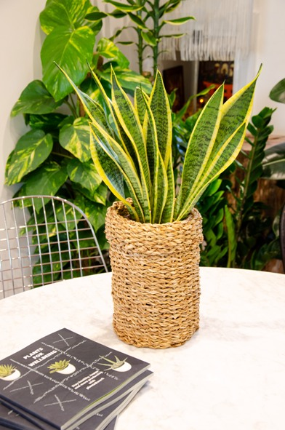

The winner of the Favourite Office Plant of the Year 2020

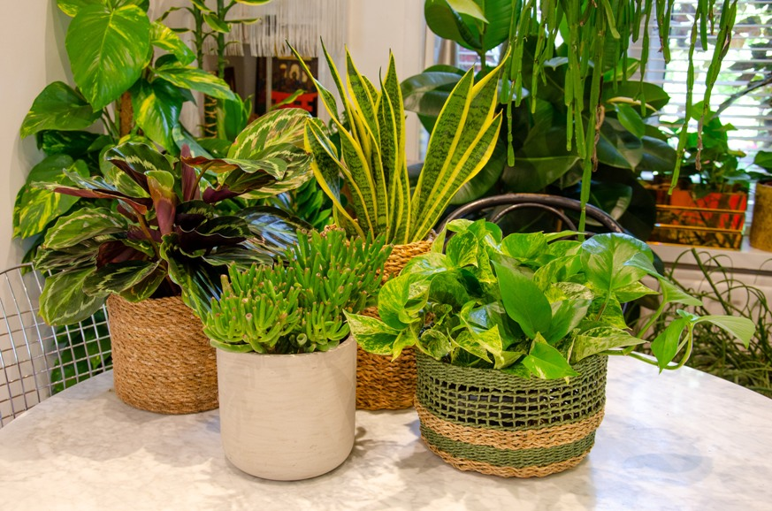

The contestants: Calathea, Crassula, Sansevieria, Scindapsus

Editor's notes
Greening the Great Indoors for Human Health and Wellbeing – Margaret Burchett
http://interiorplantscape.asn.au/wp-content/uploads/2016/04/Greening-the-Great-Indoors-for-Human-Health-and-Well-Being-Final-Report-to-HAL-2010.pdf

Potential of a Small Indoor Plant on the Desk for Reducing Office Workers’ Stress – Toyoda, Yokota and Barnes

https://journals.ashs.org/horttech/view/journals/horttech/30/1/article-p55.xml?rskey=mviVyz

The Virtual RHS Chelsea Flower Show 2020 entry from Indoor Garden Design with Malvern Garden Buildings
https://www.rhs.org.uk/shows-events/virtual-chelsea/tuesday/malvern-garden-buildings?fbclid=IwAR1ElvN_fgaBCDg2nN9wB5phpKUYqaxpoDY-QOxd4hvm0ZYqWl3aliBwkzg

