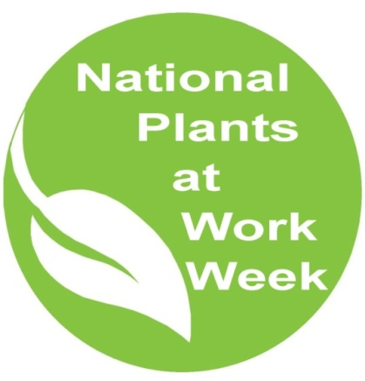

NPWW 7 x 7

National Plants at Work Week and biophilia

We all know that surrounding ourselves with plants makes a difference. Take this week to get involved with nature. It will make you feel good, improve your general health, reduce your stress levels, help you to concentrate and make you more productive.

Just take 7 minutes each day for a week ...

Daily tips
Use your 7 minutes wisely each day:

- Bring nature inside: make sure your desk has plants on it or nearby and take the time to look at them and see if they have grown or changed

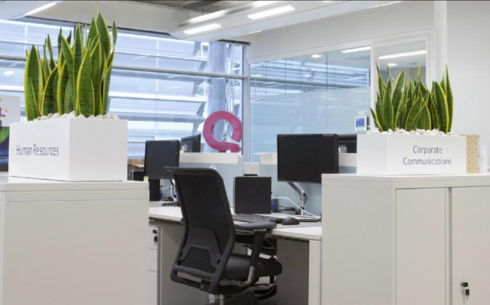

- Gaze on the beauty of nature: can you see a green space or a planted wall or roof – use your 7 minutes to really look at and enjoy your green view

- Get outside: take your coffee break outside and kick off your shoes and ‘breathe in’ nature from the feet up

- Nature at home: buy a new plant for your home office and plant bee-friendly plants outside

- Read our guide about why nature is good for you preferably somewhere ‘green’

- Suggest a way a colleague could use their 7 minutes to get back to nature

- Watch one of efig's online webinars (new this year) on YouTube

Don’t stop when National Plants at Work Week is over. Make that 7 minutes a day a lifetime habit and perhaps increase the daily allowance to 30 minutes. Download our guide about the benefits of plants (10 key facts) and keep it on your phone or on your desk.

